8
The Calvary Chronicle
Share the Gospel – Prepare Disciples –
Serve All in Christ’s Love!
August 2023
Volume 87 - Number 08
La Crónica del Calvario
¡Compartir la palabra – Preparar discípulos – Servir a todos en el amor de Cristo!
Agosto 2023
Volumen 87 – Número 08

One Church - One Congregation – One Chronicle
Una iglesia - Una Congregación – Una Crónica
08/06/2023- Tenth Sunday after Pentecost
Genesis 32:22-31 Ps. 17:1-7,15 Romans 9:1-5 Matthew 14:13-21
08/13/2023- Eleventh Sunday after Pentecost
Genesis 37:1-4,12-28 Ps. 105:1-6,16-22, 45 Romans 10:5-15 Matthew 14:22-33
08/20/2023- Twelfth Sunday after Pentecost
Genesis 45:1-5 Ps. 133 Romans 11:1-2,29-32 Matthew 15:[10-20] 21-28
08/27/2023- Thirteenth Sunday after Pentecost
Exodus 1:8-2:10 Ps. 124 Romans 12:1-8 Matthew 16:13-20

Calvary Evangelical Lutheran Church
6149 S. Kenneth Ave. Chicago, IL 60629
(773) 767-7400
Email: calvaryluther@sbcglobal.net
URL: chicagolutheran.org
facebook.com/chicagolutheran.org

1

From the Pastor’s Desk- August 2023
Do not neglect to show hospitality to strangers, for by doing that some have entertained angels without knowing it. - Hebrews 13:2
We are in midsummer. Our usual summer drop in attendance seems worse this year since on top of normal attrition, attendance has not rebounded from COVID-19. Yet even in midsummer, God has been worshipped in vibrant ways in Calvary’s sanctuary, even by those who aren’t our members.
On July 15, a youth group from St. Thomas Episcopal Church in Menasha, Wisconsin (near Appleton and Green Bay) stayed overnight at Calvary, as they had done in 2017 and 2018. Calvary was a way stop preceding their mission trip. In 2018, they traveled to Puerto Rico to help with the ongoing efforts to rebuild after hurricanes Irma and Maria devastated much of the island the previous year. This year, they went to help another organization to build houses along the U.S.-Mexican border, near Juarez, across from El Paso, Texas. This year, they walked to Midway Airport just before 3:00 a.m. to check in their large group for a very early Sunday 5:10 a.m. flight.
Between a pizza supper at Giordano’s and an early bedtime on Saturday evening, however, they had a brief worship service. Though they had planned a simple service in Luther Hall at the end of their meeting to discuss the next day’s plans before bed, one of the three ordained clergy in their group offered to preside at a simplified communion service. Another of the adult leaders played her guitar and led singing, and with very short notice, we facilitated a group of over 20 youth and six adults to share communion before their being sent forth to serve those in need. (See a photo on Calvary’s Google profile or Facebook page.)
Though our worship attendance is sparse, we want more people to attend our worship in person more regularly, and our evangelism committee has continued to meet during the summer, Calvary’s sanctuary is being used in ways beyond what most of us immediately see. Each week, Maranatha Seventh Day Adventist Church worships in our sanctuary on Saturdays, and Victory Outreach Ministries worships in it on Sunday afternoons. And occasionally, other Christians who live in, and who travel to, places far from Chicago appear for a brief time to praise God and who pray to be guided on their journeys. Let us be open to how the Holy Spirit can use Calvary even for those who are not its members, who may not be Lutheran, and who may even just be passing through on a journey to which God has called them.
In the Lord of the faithful sojourner,
Pastor Cox
2

Food for the Poor
On Sunday, July 29, 2023, the Rev. Canon Dr. Howard K. Williams was our guest preacher. He spoke about Food For The Poor, a ministry providing direct relief to the poor throughout Latin America and the Caribbean. Canon Williams shared personal witness about Food For The Poor’s mission to care for the destitute as a means of living out the Gospel mandate to love one another.

Canon Williams was ordained deacon in 1974, was ordained an Episcopal priest in 1975, and became Canon in 2004 and Archdeacon in 2006. He was a teacher and rector of churches in the islands of Jamaica, Bahamas, Turks and Caicos, and here in the USA. He has initiated and spearheaded many groups that aid women and children.

There are brochures with envelopes in the narthex for those who wish to make an individual donation to Food For The Poor, or donations may be made online at www.FoodForThePoor.org. Both the brochures and the website provide much additional information about this ministry.

Centennial Service Follow-Up
The Evangelism Committee has been reviewing dozens of digital photos from our centennial service on April 23. We are grateful for Anna, a board member of Consuelo, the counseling agency that shares Calvary’s space, who took many photos during the worship service and afterwards. The Misch family and others have sent other photos of the big day, too. Check our website www.chicagolutheran.org, our Google profile, and our Facebook page periodically throughout the summer as we determine which photos to share in which venues and post them. If anyone else has photos to share, please send them a few at a time to Morgan or Pastor Cox via email or contact us for other sharing methods.

Calvary Seniors
Calvary Seniors will be taking a break for the summer and will not meet at Calvary during July or August. Please look forward to meeting again in September or consider joining the gathering if you haven’t attended recently. Please contact Elaine Lebron or JoAlice Revas for more information.

3
Sharing Faith Stories
Can you share a faith story from your life? It might be a powerful experience of God in our lives, how you first came to faith in Christ or renewed your faith, a challenging time after which you realized that others’ prayers and God’s mercy helped you through it, why you feel uplifted at worship, how you feel strengthened or calmed through prayer or a hymn or a Bible verse, or other ways in which your faith in Christ or participation in a Christian congregation has been significant in your life. Please either write, type, or email a submission to Pastor Cox or to the church office, or feel free to discuss a possible story with him beforehand.
Let’s share the good news!


4
5

Happy Birthday!
¡Feliz Cumpleaños!
Angela Murphy August 12th
Elaine Lebron August 17th
Larry Breen August 19th
Major Kincade August 29th

Happy Anniversary!
¡feliz aniversario

Memorials – August
Candle in Memory of Kjell Sivertsen (Lois Flood)

Verses for our Times:
1 LORD, you have searched me out and known me; *
you know my sitting down and my rising up;
you discern my thoughts from afar.
2 You trace my journeys and my resting-places *
and are acquainted with all my ways.
3 Indeed, there is not a word on my lips, *
but you, O LORD, know it altogether.
4 You press upon me behind and before *
and lay your hand upon me.
5 Such knowledge is too wonderful for me; *
it is so high that I cannot attain to it.

Psalm 139:1-5
[Lutheran Book of Worship/
Book of Common Prayer translation]

6
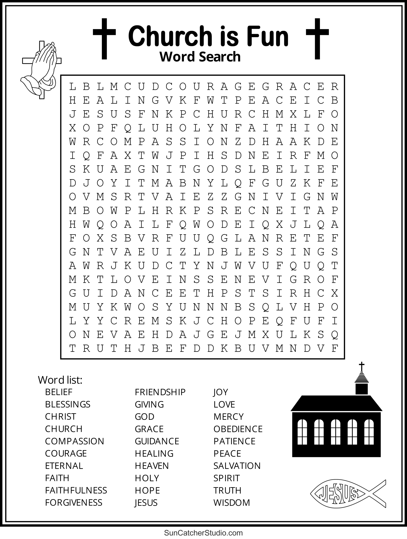

7
8

